KEKB Magnet Power Supply Control System
Aug. 2001
Tatsuro NAKAMURA @KEK

Number of the Magnets and Power Supplies
Hardware of the Magnet Power Supply Control System

PSICM and ARCNET
Functional Requirements
Structure of Software

Application Level Software

IOC Level Software
EPICS database Configuration by Oracle
Number of the Magnets and Power Supplies (in Aug. 2000)

In the Storage Rings (LER & HER)
4607 Magnets (including auxiliary coils)
2245 Power Supplies (1711 of them are for the steering magnets)
The Power Supplies are located in 8 Buildings around the Rings.

In the Injection Beam Transport Lines (positron & electron)
380 Magnets (including auxiliary coils)
276 Power Supplies
The Power Supplies are located in 3 Buildings along the Lines.
Hardware of the Magnet Power Supply Control System

It can be divided into 3 subsystems

Setting output current, ON/OFF control,

and reading various status of Power Supply

PSICM mounted in each Power Supply

(PSICM = Power Supply Interface Controller Module)

Connected to the IOC through ARCNET

(2) Current monitor
Digital Voltmeter with scanner

Connected to the IOC through GPIB
(3) Interlock system to protect Magnets and Power Supplies
Standalone PLC system

Connected to the IOC through Modbus Plus
Magnet Power Supply System in a Local Building

IOC for the Magnet Power Supply Control

Each IOC is located in a Local Control Room in the Local Building

For the Storage Rings

8 IOCs for 8 Local Building (D02,D03,D05,D06,D08,D09,D11,D12)

Each IOC has

ARCNET interface board

GPIB interface board

Only IOC in D08 has Modbus Plus interface board

For the Injection BT Lines

3 IOCs for 3 Local Building (CBT,ARS,ARW)

1 IOC in Central Control Room
Current Monitor System of the Magnet Power Supply

Interlock System of the Magnet Power Supply

PSICM and ARCNET
Configuration of Magnet Power Supply Control System

ARCNET interface board
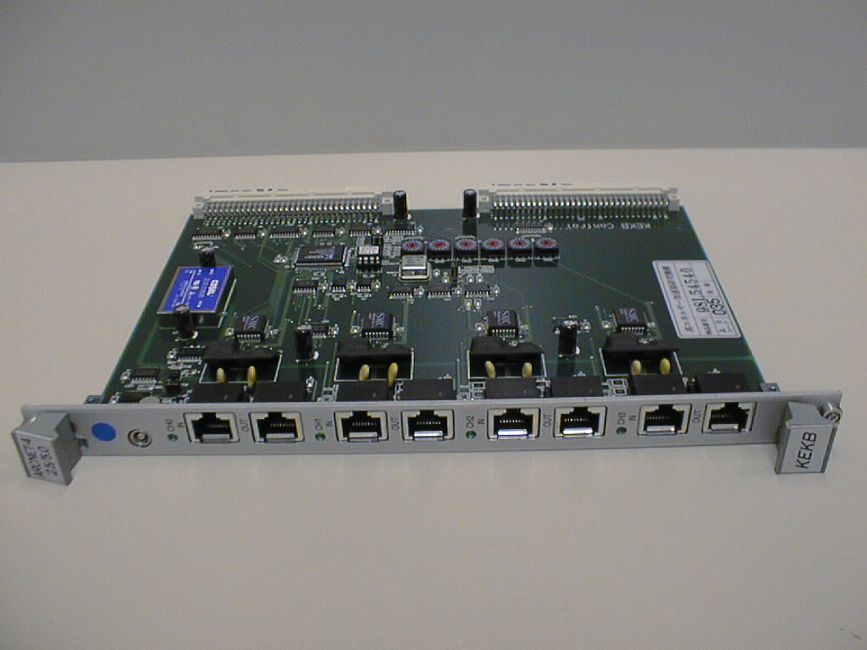

ARCNET interface boards in VME subrack
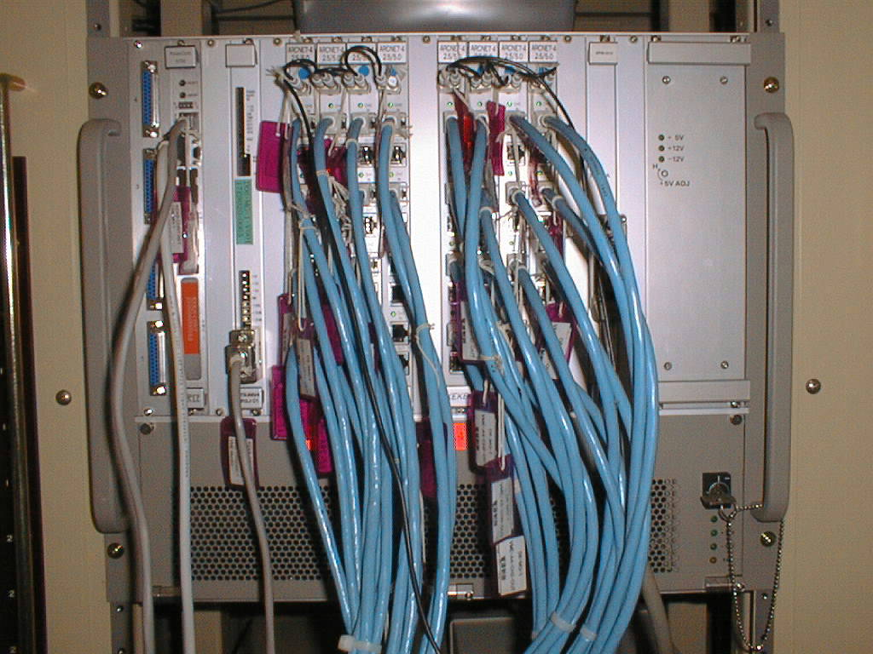

PSICM
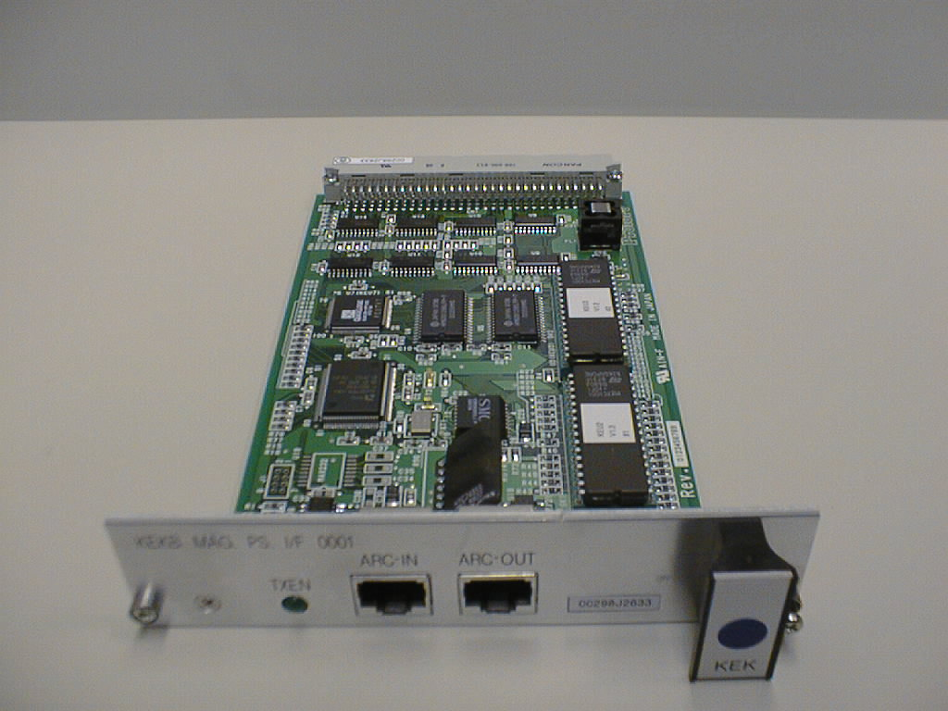

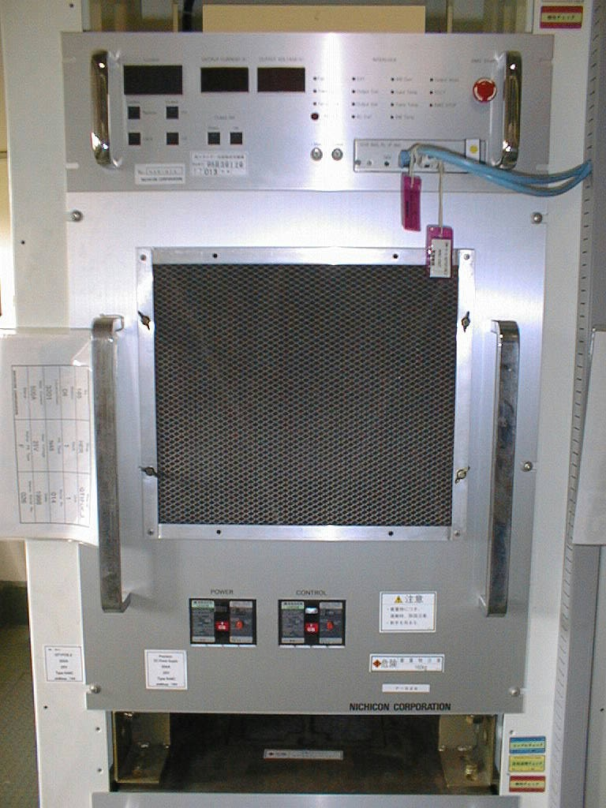
Power Supply

with PSICM

Two types of ARCNET configuration; without HUB / with HUB

ARCNET HUB and Power Supplies with PSICM
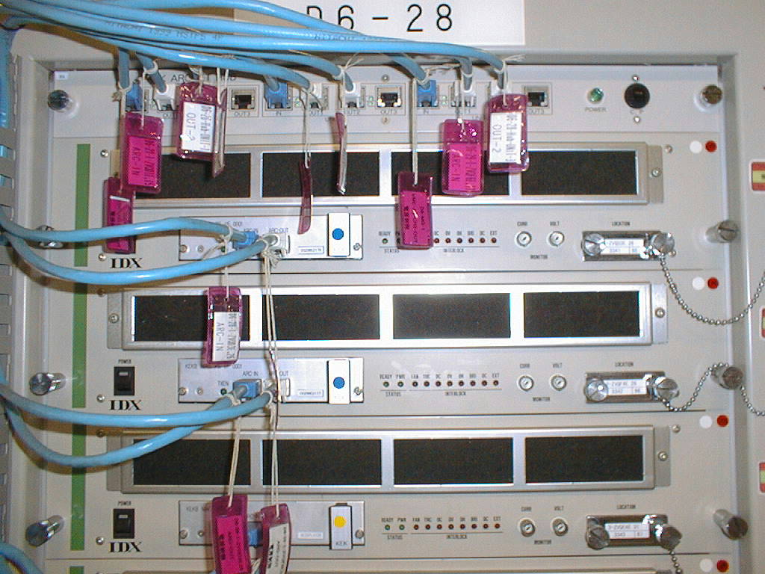

PSICM (Power Supply Interface Controller Module)

An ARCNET interface board for the power supply developed at KEK.

3U Euro-card format (100mm × 160mm)

It can be plugged into the power supply

Connection to the power supply

DIN 64-pin connector

General-purpose 16 bits I/O lines

Dedicated pulse output lines

Connection to the IOC

STP (shielded twisted pair) cable with 2 conductor pairs

One for ARCNET

The other for the Start Pulse for the synchronous operation

Special Function of the PSICM

PSICM can change the output current with an arbitrary tracking curve.

The tracking pattern data are sent from IOC through ARCNET.

Timing System (for the Magnet and Beam Monitor)

Functional Requirements

(1) The power supply should be controlled not only by current (in ampere)

but also by the abstracted parameter of beam optics such as

K1 for a Q-magnet, K0 for a steering magnet.

We generically call such parameters “K-values” for simplicity.

(2) An arbitrary number of power supplies should be able to change their

current synchronously to keep stored beam.

We call this operation “Synchronous Operation”.

(3) The power supply should have the function called “Standardization”.

It resets the hysteresis of the magnetic field to the standard position.

There are 2 other similar methods to set current; “Sequence Setting”

and “Simple Standardize Setting”, in which the current is set along

the standard hysteresis loop with less loop count.
Direct Setting & Sequence Setting

Standardization
Example of Application Level Software

PS control panel
Basic operation on each power supply
Operation on multiple power supplies.
Monitor various status of the power supply
Static parameters from RDB are also shown on the panel.

Written in Python with tkinter (tcl/tk GUI)

Access to the IOCs through CA
Example: set a K-value (k) to a Q-magnet
caput(“MGLPS:QT5NFP:KDIR”,k)
Example: read power supply current monitored by the DV

current = caget(“MGLPS:QT5NFP:IMON”)

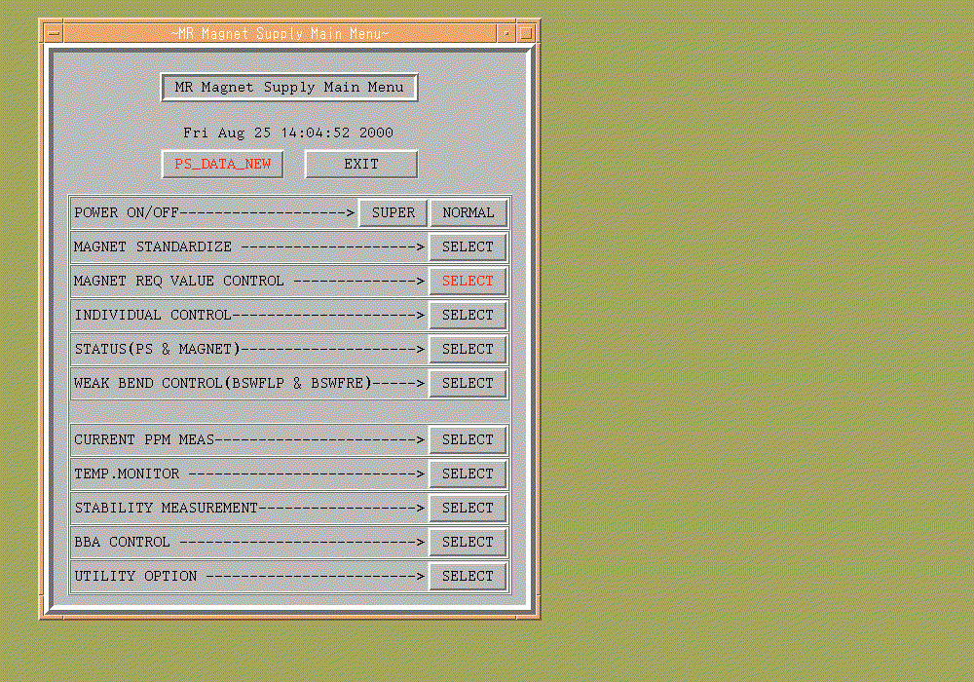
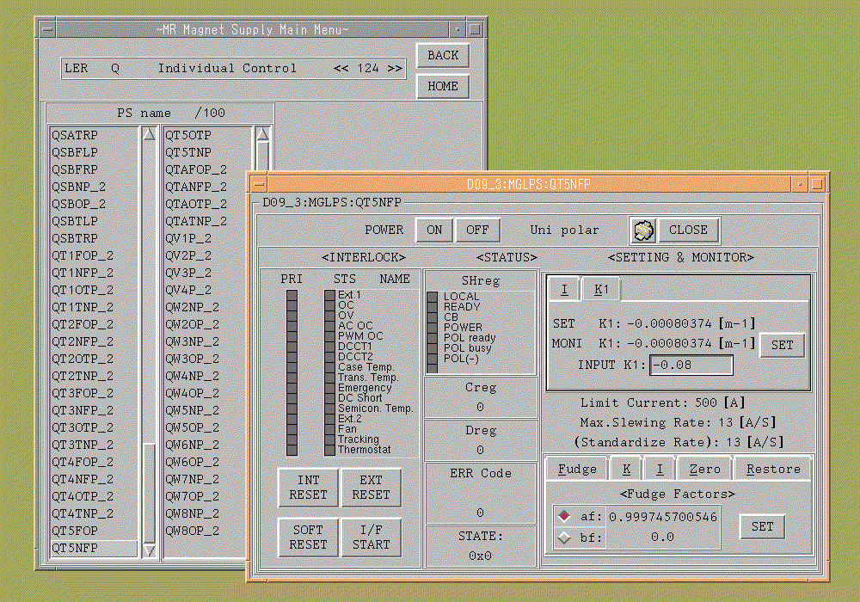
IOC Level Software

Status input record

ARCNET packet

output record

Record to set K-value

“PS-record”

UNIX Host Machine

IOC

Application

PS control panel

A set of records for a Power Supply

From ARCNET

To ARCNET

“MGLPS:QT5NFP:KDIR”

CA
PS-record
Most of the control logics are implemented in the PS-record.
They are written in C.
Conversion between K-value and current
Calculate tracking pattern data
Sequence control of the Standardization
Inhibit some operation under some condition (Software Interlock)
etc.

PS-record holds many characteristic constants in its fields

Maximum/Minimum Current

Ramping Speed and Loop Count of Standardization

Polynomial Coefficients of the Magnetic Excitation Curve

etc.

Conversion from K-value to Digital setting value

Record Support
Some record types are developed at KEK.
Record type of the PS-record: “hugesub”
“hugesub” is essentially a large size (more fields) subroutine record.

Device Support and Driver Support
The elemental services of the Driver Support are transmission and
receiving single packet.
These packets are queued.

The Device Support also provides single packet I/O.
Example of SAD Application & Synchronous Operation

CCC (Continuous Closed Orbit Correction)
Read BPMs -> Calculate Orbit -> Set Steering Magnet properly
Continuous Operation
Save/Restore Data (BPM / Steering setting / Reference orbit)
Also works as server for other application which use Steering Magnet

Written in SAD with tkinter (tcl/tk GUI)
Basically the steering magnets are set by Synchronous Operation.
Synchronous Operation Server
PS1
PS2
PS3
PS-records
Synchronous Operation Server
CCC
(Application Program)
UNIX Host Machine
Power Supply List

K-value List
Interface records

Trigger record
IOC in the Central Control Room

IOCs in the Local Building
IOC for Timing System
ARCNET
Start Signal
EPICS database Configuration by Oracle
EPICS database Template File “BTMGPS.db”
：
：
record(ai,"$(HEAD):$(NAME):INP_AMP") {
field(DESC,"analog input record")
field(SCAN,"Passive")
field(PINI,"NO")
field(PHAS,"0")
field(EVNT,"0")
field(DTYP,"Soft Channel")
field(DISV,"1")
field(SDIS,"0.000000000000000e+00")
field(DISS,"NO_ALARM")
field(PRIO,"LOW")
field(FLNK,"$(HEAD):$(NAME):INP_AMP_PUT.VAL")
field(INP,"0.000000000000000e+00")
field(PREC,"0")
field(LINR,"NO CONVERSION")
field(EGUF,"0.0000000e+00")
field(EGUL,"0.0000000e+00")
field(EGU,"volts")
field(HOPR,"$(PS_MAX)")
field(LOPR,"$(PS_MIN)")
field(AOFF,"0.0000000e+00")
：
：
EPICS database Parameter File “MGPS_B.dbprm”

：
：
file BTMGPS.db {
{
CHANNEL="1",
DV_ADR="1",
DV_AO=".00827",
DV_AS="1.0000389",
DV_CH="101",
DV_K="20",
DV_P_HI="65",
DV_P_LO="5",
HEAD="BTePS",
NAME="B0E",
NODE_NO="1",
PS_MAX="200",
PS_MIN="0",
THRU_COEFF=" 3.333333"
}
}
：
：
How to maintain the parameter files ?

Some parameters are common to the same device type.

Some parameters appear in the different files.

How to keep consistency of these parameters ?

→ We chose an RDB

RDB is the source of information.

All of the parameter files should be derived from the RDB.

Maintenance of the parameters is concentrated on the RDB.
Upgrade

PF-AR upgrade (this year, 2001)

Control System: HIDIC & NODAL → VME, Unix & EPICS
Interface of Magnet Power Supplies: CAMAC → ARCNET
Also installing new Power Supplies for Steerings & Backlegs.

Control System for KEKB Magnet PS is reusable for PF-AR ?
Hardware:
YES (ARCNET and PSICM are enough for PF-AR)
Software:
Partially YES
Most of its functions are enough
but
PF-AR needs synchronous ramping (acceleration).
→ Now developing additional db and code

